Project is from Page 16

Project 01

Project Overview
Your organization is implementing continuous integration (CI) practices to streamline the software development lifecycle. As part of this initiative, you will create a Jenkins declarative pipeline for building a simple Maven project hosted on GitHub. This project aims to automate the build process, ensure code quality, and facilitate continuous delivery (CD).

Objectives
- Create a Jenkins pipeline script using declarative syntax.
- Clone a Maven project from a specified GitHub repository.
- Execute the build process and run unit tests.
- Archive build artifacts.
- Provide clear feedback on build status through Jenkins' UI and console output.

Instructions
- Setup Jenkins Job
  - Create a new Jenkins pipeline job.
  - Configure the job to pull the Jenkinsfile from the GitHub repository.

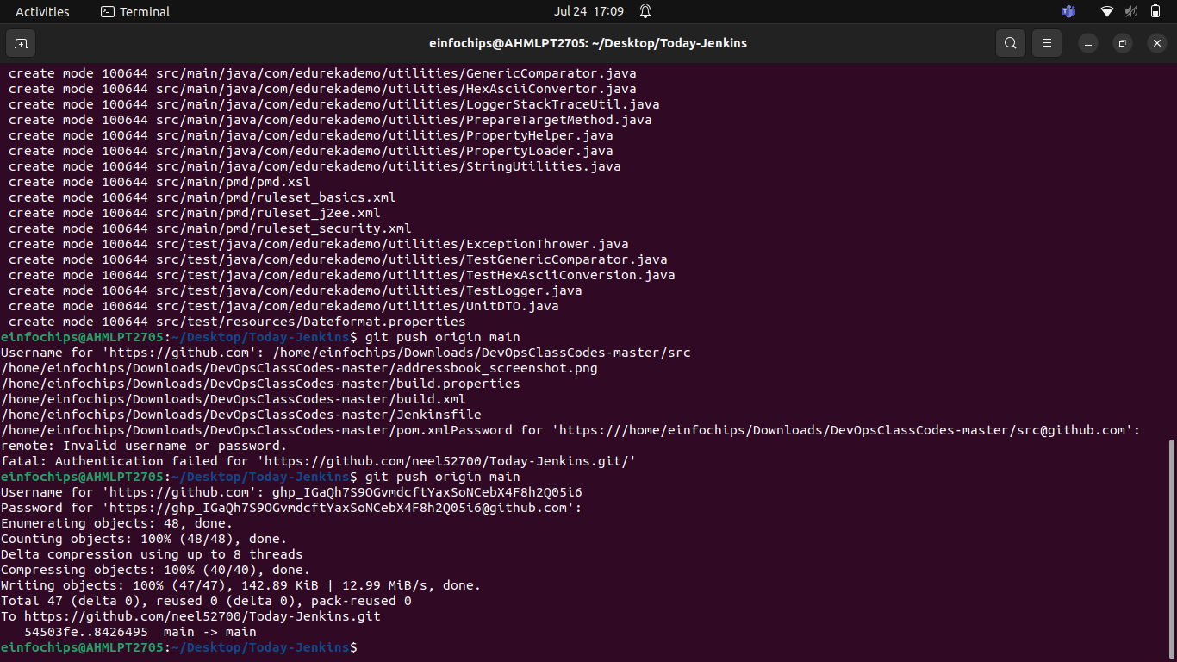

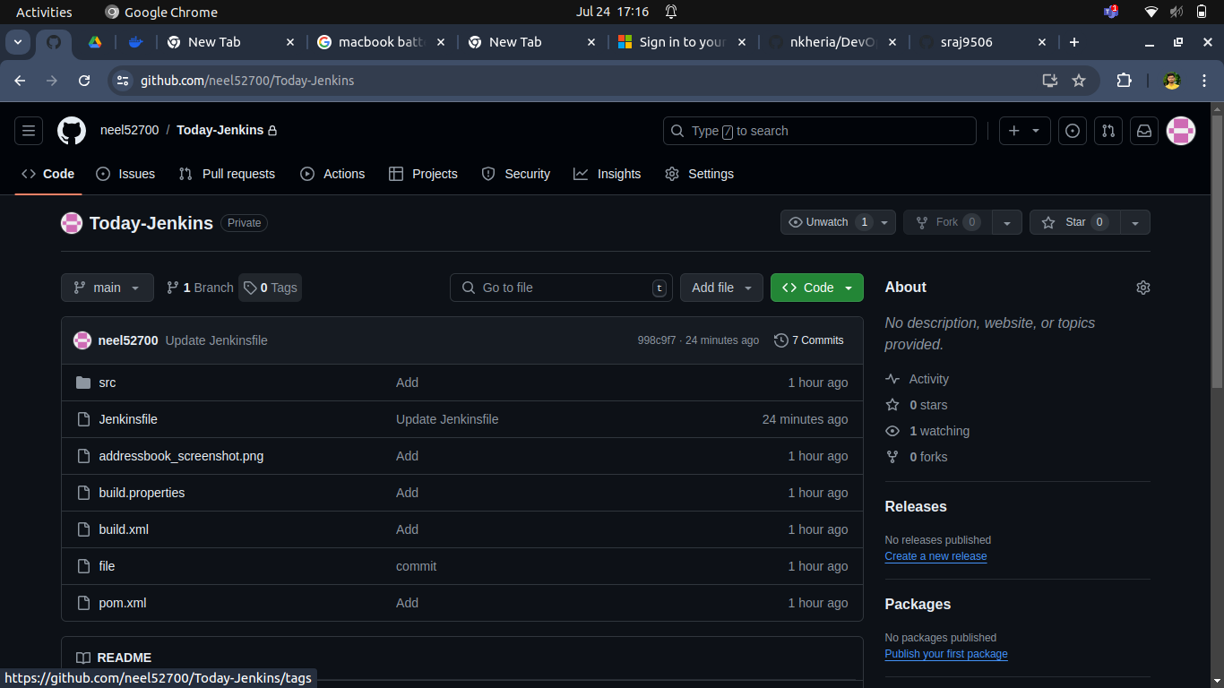

- Create Jenkinsfile
  - Write a declarative pipeline script (Jenkinsfile) that includes the following stages:
    - Clone Repository: Clone the Maven project from the GitHub repository.
    - Build: Execute the Maven build process (mvn clean install).
    - Test: Run unit tests as part of the Maven build.
    - Archive Artifacts: Archive the build artifacts for future use.

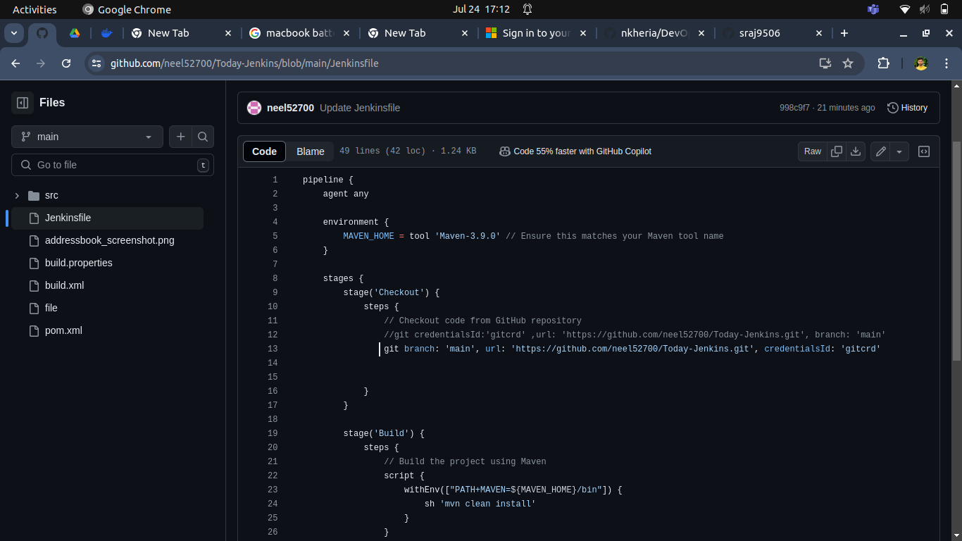

1.Clone Repository
2.Build:
3.Test
4.Archive Artifacts
5.Jenkinsfile

Create a Jenkins File

- Configure Pipeline Parameters
  - Allow the pipeline to accept parameters such as Maven goals and options for flexibility.
  - Ensure the pipeline can be easily modified for different build configurations.
- Run the Pipeline
  - Trigger the Jenkins pipeline job manually or set up a webhook for automatic triggering on GitHub repository changes.
  - Monitor the build process through Jenkins' UI and console output.

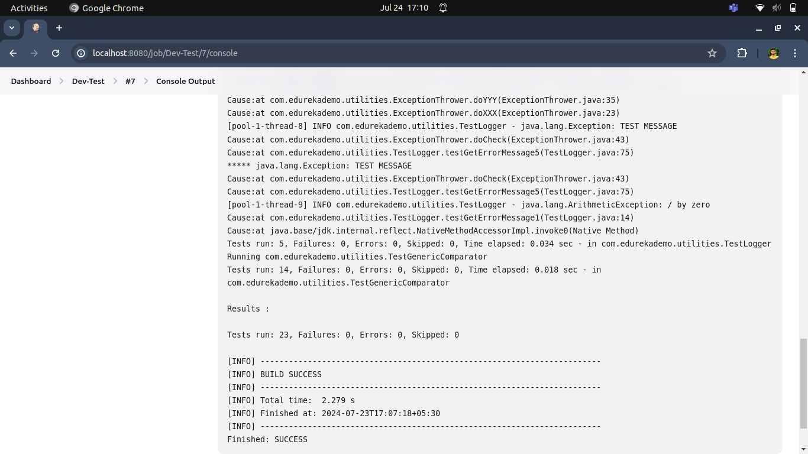

1. Trigger the Job
2.Monitor Build:
  - Go to the job's page in Jenkins.
  - Click on the build number to view the build's status and console output.

- Deliverables

